**LINUX Lab : Install a virtual machine on personal computer CISCO LAB**

**Objectives**

1. Prepare a computer for virtualization.
2. Import a Virtual Machine into VirtualBox Inventory.

**Background / Scenario**

Virtualization allows multiple virtual computers, called **virtual machines (VMs)**, to run on a single physical computer, called the **host**. Virtual machines, also called **guests**, operate independently within the host.

With modern multicore processors and sufficient RAM, virtualization has become feasible for personal computers. In this lab, we downloaded and imported a pre-configured virtual machine image file to use Linux-based virtual machines for future labs.

**Required Resources**

* PC with at least 4 GB RAM and 50 GB free disk space.
* High-speed internet to download VirtualBox and VM images (~5 GB).
* Oracle VirtualBox software and Extension Pack.

**Note:** For 64-bit VMs, the host must have 64-bit support and hardware virtualization enabled in BIOS.

**Part 1: Prepare a Host Computer for Virtualization**

**Step 1: Download and Install VirtualBox**

1. Navigated to [https://www.virtualbox.org](https://www.virtualbox.org/).
2. Downloaded the appropriate VirtualBox installer for Windows 10.
3. Ran the installer and accepted default settings.

**Step 2: Install VirtualBox Extension Pack**

1. Downloaded the **Oracle VM VirtualBox Extension Pack** from the VirtualBox website.
2. Installed the Extension Pack to support USB 2.0/3.0, RDP, and other advanced features.

**Step 3: Download Virtual Machine Image Files**

1. Downloaded the **CSE-LABVM** and **Security Workstation OVA** files (~5 GB).
2. These files are packaged in **OVF (Open Virtualization Format)** standard, which contains all necessary files for VM deployment.

**Part 2: Import Virtual Machine into VirtualBox Inventory**

**Step 1: Import CSE-LABVM**

1. Opened VirtualBox → **File → Import Appliance**.
2. Selected the **CSE-LABVM OVA** file.
3. In the appliance settings, set:
   * Machine Base Folder → Documents folder
   * MAC Address Policy → Generate new MAC addresses
4. Clicked **Import**.

**Result:** CSE-LABVM appeared in VirtualBox inventory.

**Step 2: Start CSE-LABVM and Log In**

1. Selected **CSE-LABVM** in the inventory.
2. Clicked **Start** (green arrow).
3. VM booted automatically and logged in.

**Login credentials:**

* Username: cisco
* Password: password

**Notes:**

* Mouse and keyboard are captured inside the VM window.
* Press **Right CTRL** to release control back to host.

**Step 3: Familiarize with CSE-LABVM**

**Launcher Icons:**

* cisco's Home → User home directory
* DPI Scaling → Adjust resolution
* Firefox Web Browser → Internet access
* jcryptool → Cryptography tool
* Terminal → Command line access
* Wireshark → Packet sniffer

**Tested IP Address:**

* Loopback: 127.0.0.2/8
* Ethernet: 10.0.3.15/24

**Tested Internet Access:**

* Successfully opened Firefox and navigated to Google.

**Step 4: Shutdown CSE-LABVM**

1. Pressed **Right CTRL** to release cursor.
2. Chose **File → Close → Save the machine state**.
3. VM can now resume from the saved state in the future.

**Step 5: Import Security Workstation VM**

1. Repeated import steps for **Security Workstation OVA**.
2. Started the VM and logged in:
   * Username: analyst
   * Password: cyberops
3. Addressed any Ethernet adapter error by changing network settings.

**Step 6: Familiarize with Security Workstation**

* Based on **Arch Linux**.
* Contains minimal services to reduce resource usage.
* Further exploration to be done in future labs.

**Step 7: Shutdown Security Workstation**

* Chose **File → Close → Save the machine state**.

**Reflection**

**Advantages of Virtual Machines:**

* Cost-efficient
* Hardware virtualization
* Easy backup and snapshots

**Disadvantages of Virtual Machines:**

* Performance overhead
* Potential security risks

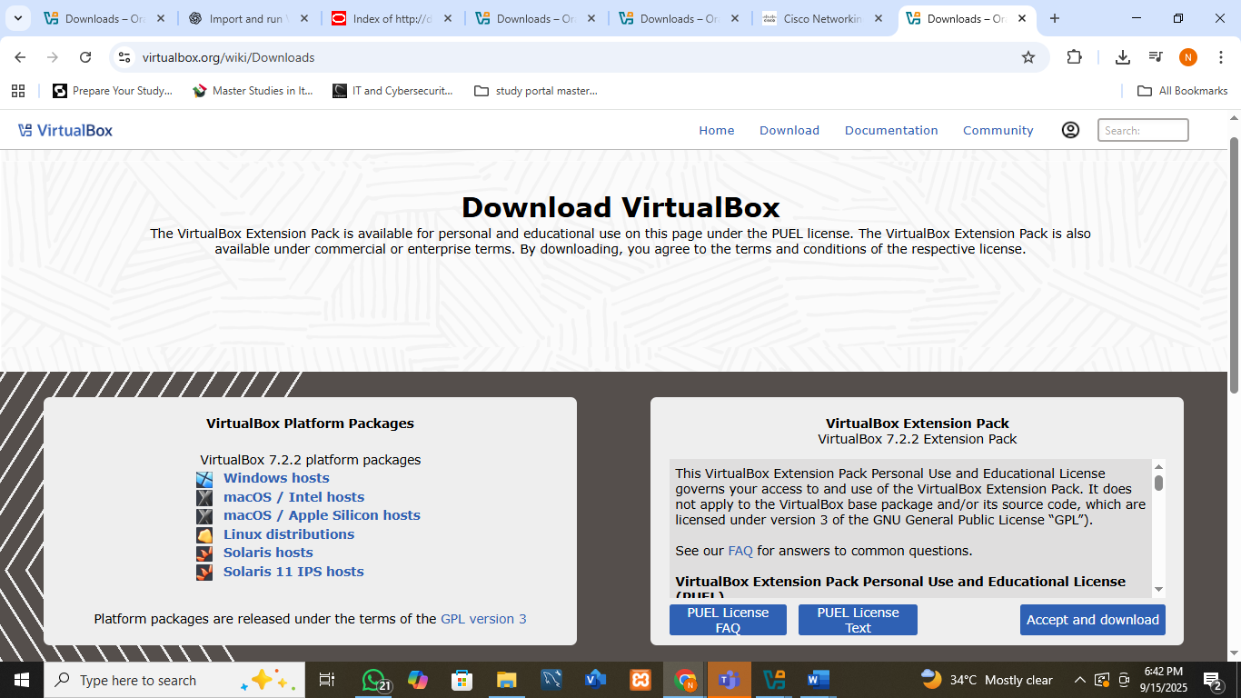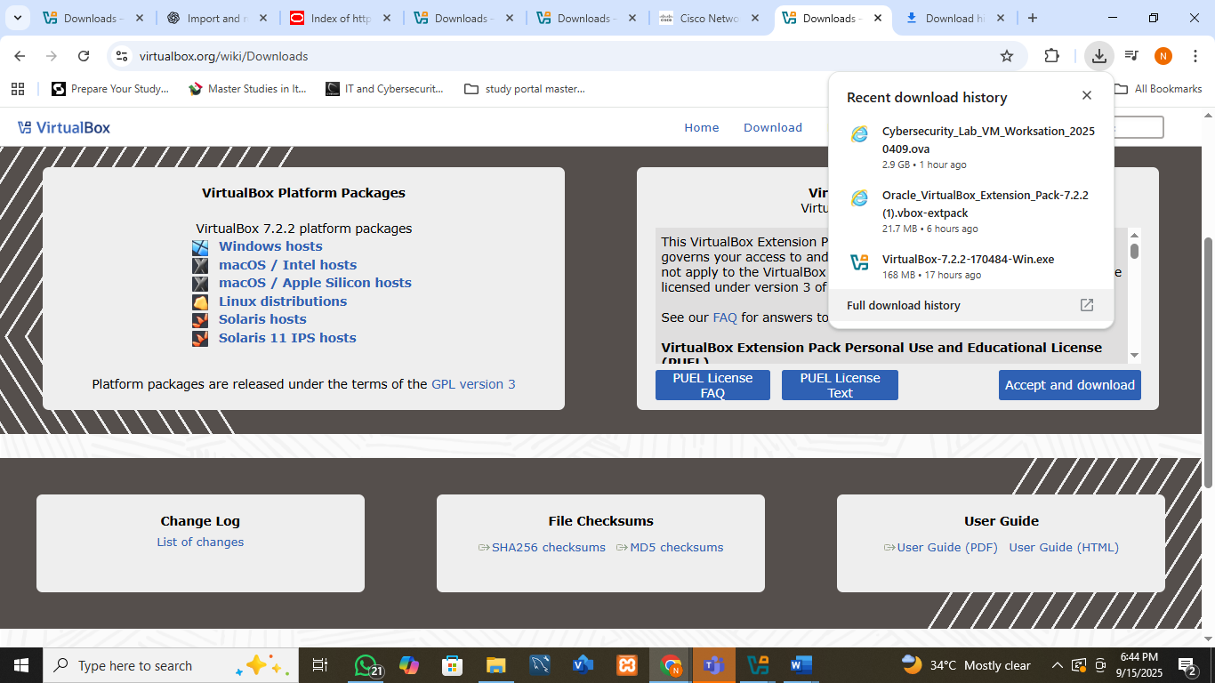

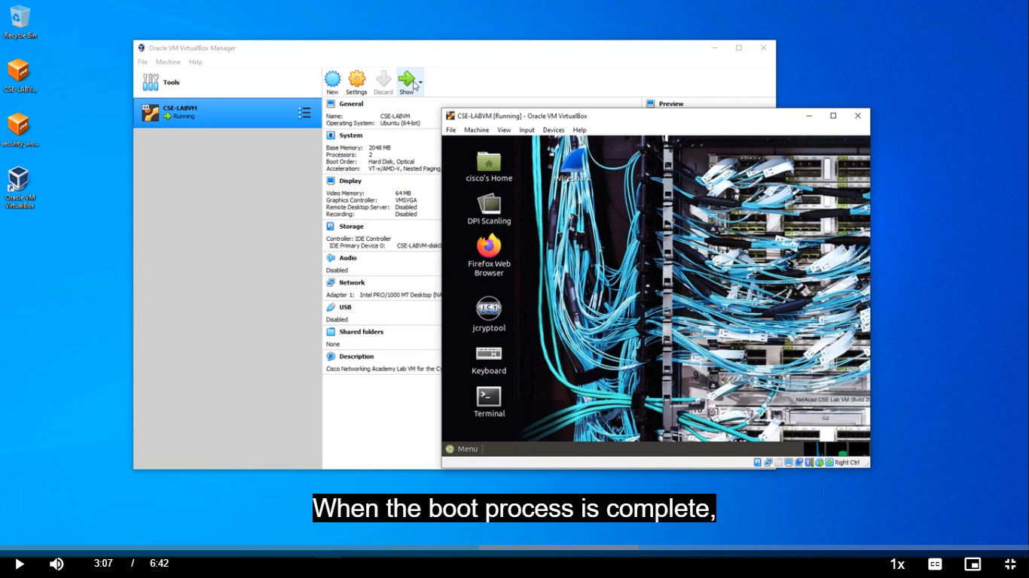

**Conclusion:**  
The lab successfully demonstrated how to prepare a host computer for virtualization, install VirtualBox and Extension Pack, import Linux virtual machines, and use them effectively for lab exercises. Both CSE-LABVM and Security Workstation are ready for use subsequent labs.